**Lab Submission 04.**

**Modifying Existing Tables in Hive**

**Instructor: Basit Ali**

**Assignment-02**

1. **Change table name to companies (Investors table).**
   1. **If table does not exist write query to create external table investors**
   2. **(user/hive/warehouse/investors/*.csv exists)**

CREATE EXTERNAL TABLE IF NOT EXISTS DEFAULT.INVESTORS  
(NAME STRING, AMOUNT INT,SHARE DECIMAL(4,3))  
ROW FORMAT DELIMITED  
FIELDS TERMINATED BY ',';

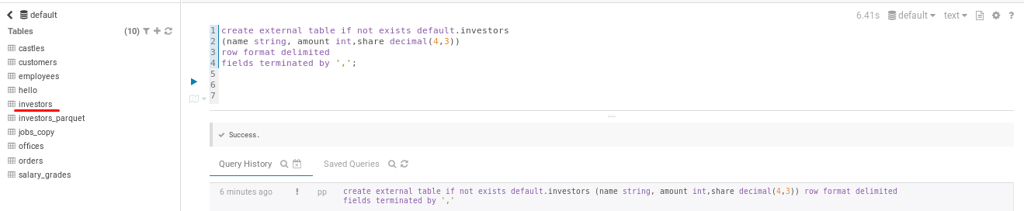

ALTER TABLE INVESTORS RENAME TO COMPANIES;

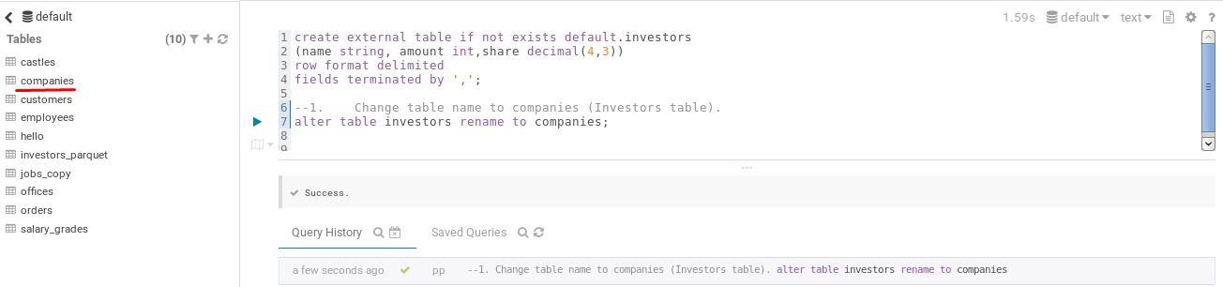

1. **Select * from companies**

SELECT * FROM COMPANIES;

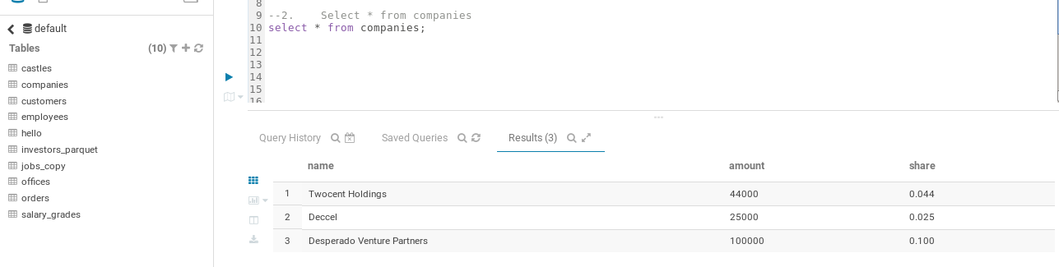

1. Change the name back to investors and verify the change.

ALTER TABLE COMPANIES RENAME TO INVESTORS;

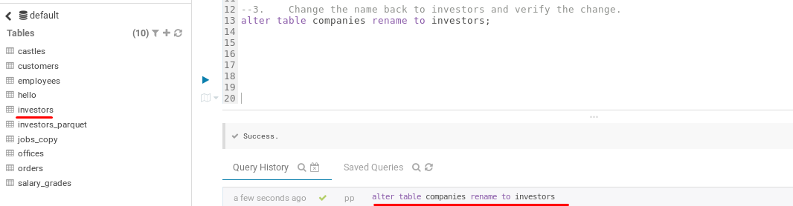

1. **Move investor table to fun database**

ALTER TABLE DEFAULT.INVESTORS RENAME TO FUN.INVESTORS;

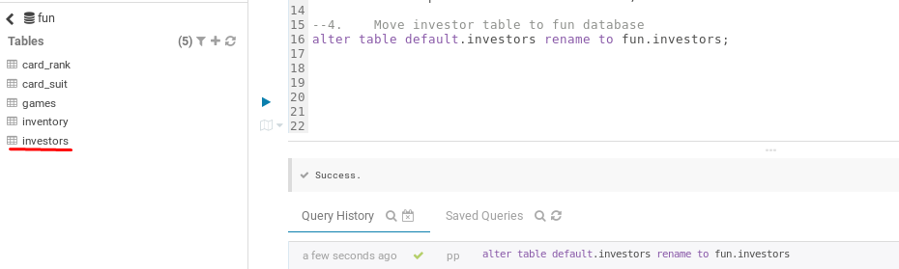

1. **Check the Hive warehouse directory and find investors table files. Did it change?**

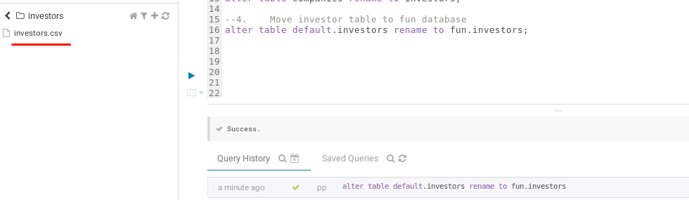

1. **Change the directory back to default and verify the change.**

ALTER TABLE FUN.INVESTORS RENAME TO DEFAULT.INVESTORS;

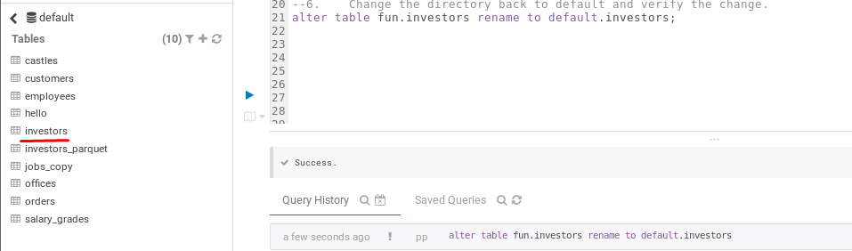

1. Change the column amount to holdings.

ALTER TABLE DEFAULT.INVESTORS CHANGE AMOUNT HOLDINGS INT;

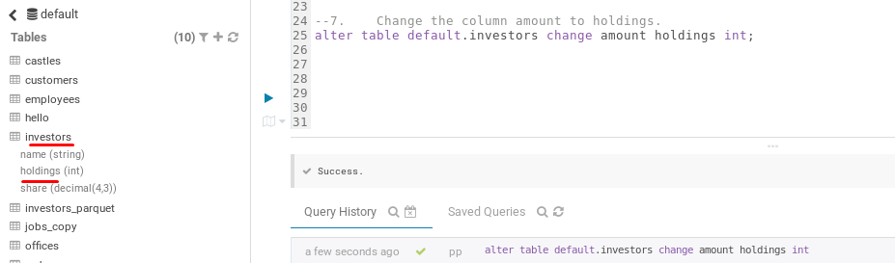

1. Verify the change. (Select *)

SELECT * FROM INVESTORS;

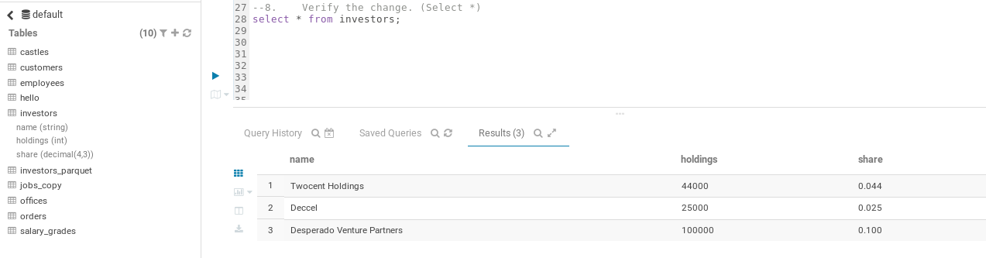

1. **Change the column amount from INT to BIGINT.**

ALTER TABLE DEFAULT.INVESTORS CHANGE HOLDINGS HOLDINGS BIGINT;

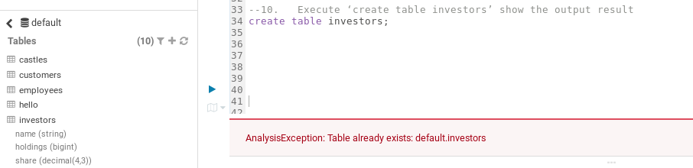

1. **Execute ‘create table investors’ show the output result**

CREATE TABLE INVESTORS;



1. **Use Hive to put the amount column at the end.**

ALTER TABLE INVESTORS CHANGE HOLDINGS HOLDINGS BIGINT AFTER SHARE;

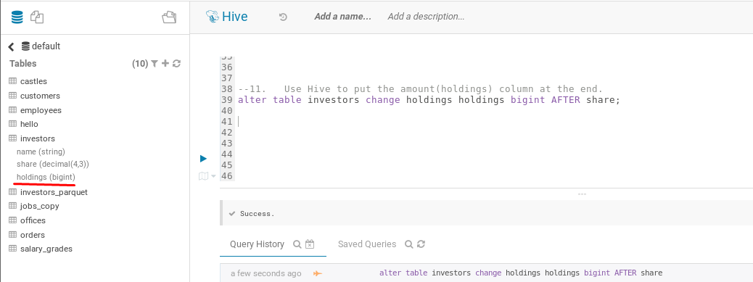

1. **Use Impala to drop a column(share) add screenshot and then add it back add screenshot.**

ALTER TABLE investors DROP column share;



